COMPLETION & EXERCISE REVIEW
MSW Component Network
Boundary Tests
Exercise 02 | Case dashboard app
Prepared: 30 July 2026
Scope: Implementation, browser evidence, verification, and learning-value review
VERDICT Helpful for juniors and early mid-level engineers once the starter is aligned with the brief. For seniors, it is a useful warm-up, but not a strong standalone assessment without concurrency, schema-drift, or mutation-boundary extensions.

Completed outcome
The static lab-contract page was converted into a real network-backed case dashboard. The implementation now exposes observable loading, success, server-empty, filtered-empty, error, and retry states through accessible UI semantics.
- Strict MSW Node server with a default GET /api/cases handler, per-test overrides, reset after each test, and failure on unhandled requests.
- Five Testing Library component tests covering the required state transitions through the network boundary.
- One role- and label-based Playwright smoke test with routed API data, traces, and a reviewed browser screenshot.
- Ten fresh component runs, ten repeated Chromium runs, and a complete lint/typecheck/build gate.

Measured result
Component suite: 2 files, 7 tests passed; 5 dashboard state tests plus 2 existing scoring tests.
Stability: 10/10 fresh Vitest processes and 10/10 Chromium repetitions passed.
Production gate: Lint, contract check, formatting, typecheck, and Vite build all passed.

Learning-value assessment
The exercise targets an important testing boundary: control network behavior while asserting what a user can actually observe. That combination teaches more durable habits than mocking component internals or replacing global fetch.

Junior suitability - strong with scaffolding
Rating: 8/10 after starter repairs; 5/10 as currently packaged.
- Concrete states make the learning objective visible and easy to review.
- MSW teaches request-level control without coupling assertions to implementation details.
- Testing Library roles and labels reinforce accessibility and resilient test design together.
- The retry path introduces a small but realistic state transition rather than a static snapshot.

Senior suitability - limited as a standalone assessment
Rating: 4/10 for senior differentiation; 7/10 as a short calibration exercise.
A senior engineer should complete the core boundary quickly. The current scope does not reveal much about race conditions, cancellation, request contracts, cache behavior, optimistic updates, malformed payloads, or CI diagnostics - the areas where senior judgment becomes more visible.

What works especially well
- The mission is outcome-oriented: test UI states, do not couple to the real service.
- Loading, empty, error, and filtered states form a compact state-model exercise.
- Required evidence encourages verification rather than a code-only handoff.

Material packaging gap
The supplied app did not match the stated mission. It rendered a static exercise-contract dashboard; the dormant workflow service returned in-memory data after a timer and never crossed a network boundary. No MSW dependency or dashboard component test existed. Repairing the application therefore became a prerequisite, making the advertised 30-minute limit unreliable.

Thirty-minute feasibility
Current repository: Unreliable for juniors; feasible only for an experienced engineer who first diagnoses the starter mismatch.
With a coherent starter: Realistic: 5 minutes inspect, 15 minutes author handlers/tests, 5 minutes stabilize, 5 minutes capture evidence.

Recommended exercise improvements
Keep the state-boundary mission, but make the starter and rubric precise enough that the timebox measures testing skill rather than repository reconstruction.
- Align the starter with the brief. Mount the case dashboard, make it call GET /api/cases, and include one intentionally weak component test. Learners should improve coverage, not invent the missing product flow.
- Pin the toolchain. Commit a lockfile, declare the supported Node version, and document the Playwright browser install. This removes setup variance from a 30-minute exercise.
- Publish acceptance criteria. Require distinct server-empty and filter-empty messages, a visible retry affordance, strict unhandled-request behavior, and handler reset after every test.
- Split core and stretch tracks. Keep the five-state MSW suite as the junior core. Add senior extensions for malformed payloads, rapid filter changes, request cancellation, mutation rollback, and request-shape assertions.
- Provide an evidence template. List the exact verification commands and required artifacts: component output, repeated run, browser screenshot or trace, and selector/mock audit.
- Use a scoring rubric. Score boundary fidelity, user-visible assertions, test isolation, accessibility-first queries, recovery behavior, and evidence quality separately.

Suggested revised challenge structure
Core - 30 minutes: Add MSW setup and handlers; cover loading, success, server-empty, error/retry, and filtered-empty; run the component suite twice.
Senior stretch - 20 minutes: Cover malformed data and stale-response races; verify request parameters; explain why the chosen boundary belongs at component rather than browser level.
Verification: Run lint, component tests, typecheck, build, and a role-based browser smoke. Attach one screenshot and repeat-run output.

Recommended rubric
Criterion | Weight | Observable standard
Network boundary | 25% | MSW handles the real request; no global fetch mock.
State coverage | 25% | All required states and retry transition are observable.
Test resilience | 20% | Roles/labels, no sleeps, isolated handlers.
Code quality | 15% | Small client boundary, response validation, clear state model.
Evidence | 15% | Passing output, repetition, browser artifact, concise notes.

Implementation evidence
The completed exercise uses a strict MSW server for component tests and a routed browser response for the smoke test. Assertions remain at the accessibility and user-visible text layer.
State | Boundary | Primary query | Expected outcome
Loading | Delayed 200 | Named status | Queue replaces loader
Success | Default 200 | Case headings | Count and records visible
Server empty | 200 with [] | Empty copy | No filters or queue cards
Filtered empty | Loaded data | Labeled controls | Distinct no-match copy
Error / retry | 503 then 200 | Alert + Retry | Queue recovers

Browser evidence
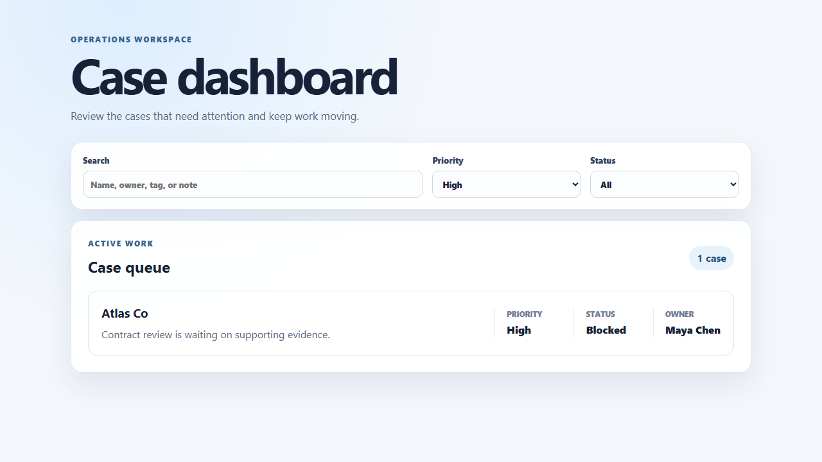
Figure 1. Chromium smoke test after selecting High priority.

Verification record
Repository gate: npm run agent:check - passed all checks and built 32 modules.
Component stability: 10 fresh processes passed.
Browser stability: 10 tests using 2 workers passed in 1.4 minutes.
Anti-pattern audit: No fetch mocks, spies, timeout sleeps, CSS locators, or querySelector calls in the added tests.

